LAB#12
BACKUP AND RESTORATION IN MONGODB

Objectives :

To learn about backup and restoration
To implement different methods of backup by using mongodump.
To implement different methods of restoration by using mongorestore.

Theory :
Data backup is one of the most highly required processes for any database management system as data can be lost or get corrupted to overcome these drawbacks we need database backup. Database backup is a copy of a database that already exists. In MongoDB, mongodump tool is used to take the data backup. And mongorestore tool is used to restore the backup data.

Lab Tasks :

1) Create a backup for all the databases.
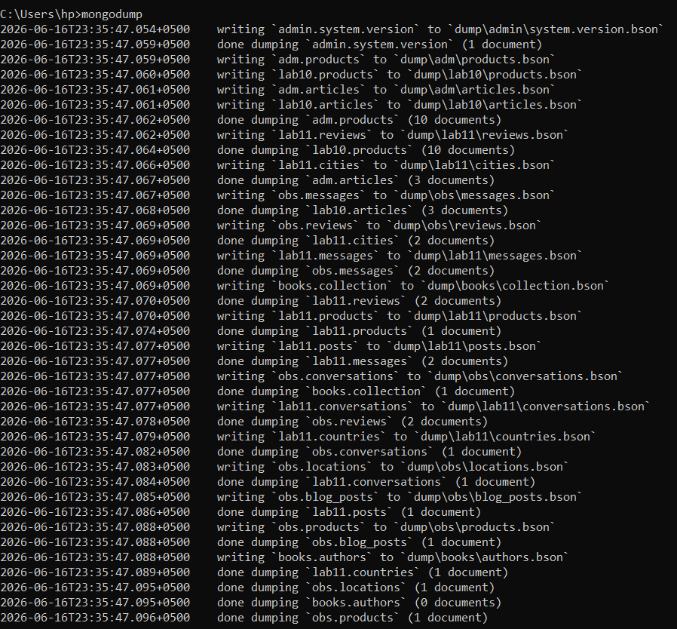

2) Create a backup for the specified database
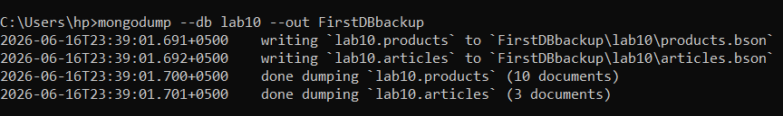

3) Delete the specified database and restore it.

Dropping the database
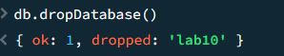
Restoring it
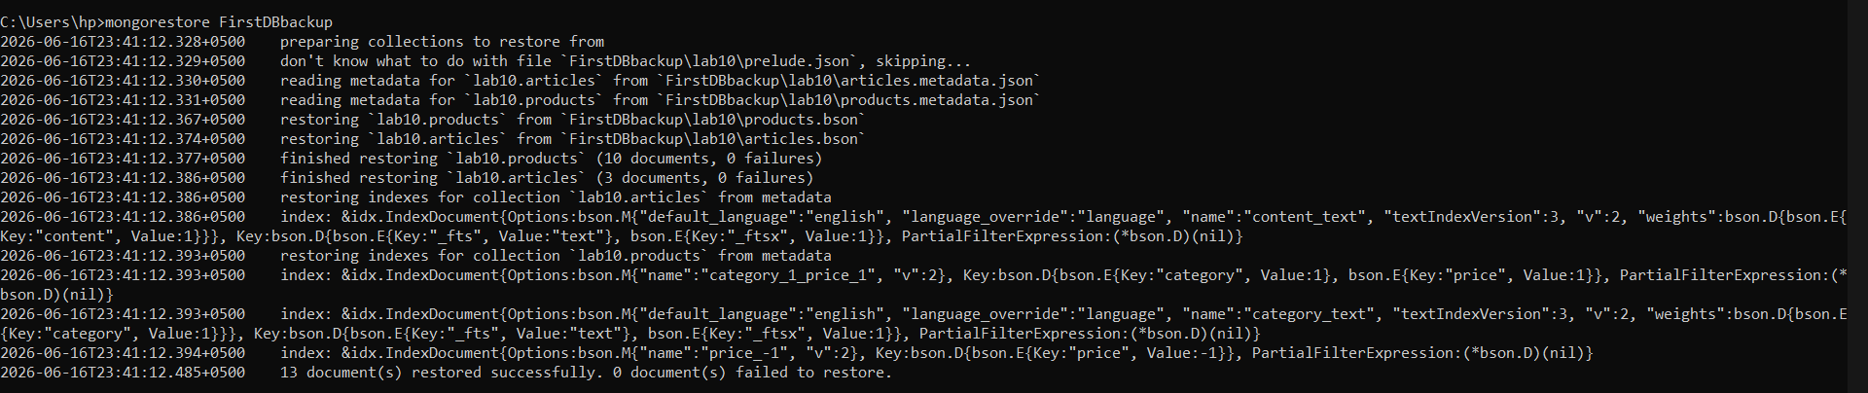
Proof of restoration
